Project Design Phase-II
Data Flow Diagram & User Stories
Date | 07 September 2026
Team ID | SWUID2026190373
Project Name | ServiceNow-Based Employee Laptop Request Application
Maximum Marks | 4 Marks

Data Flow Diagram (DFD)
The Data Flow Diagram represents how information moves through the ServiceNow-Based Employee Laptop Request Application, from employee request submission through manager approval, status updates, notifications, and fulfillment.
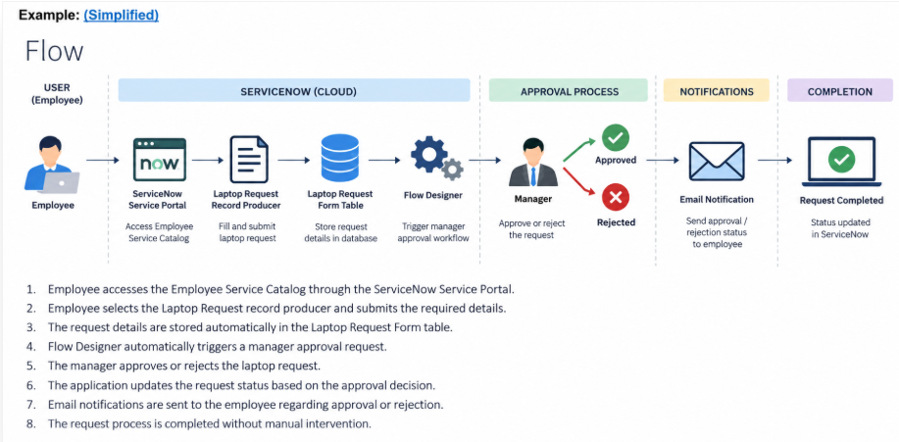
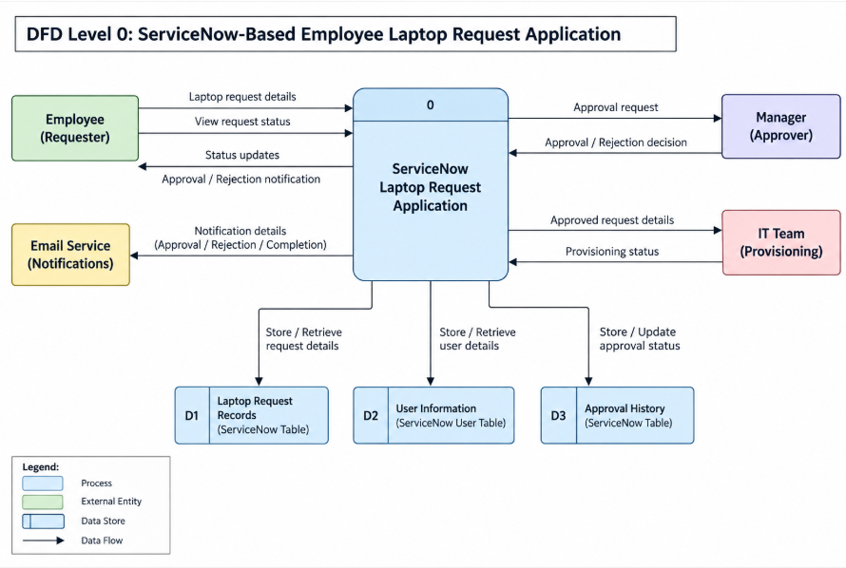
User Stories
The following user stories describe the main functional requirements of the application.
User Type | Functional Requirement (Epic) | User Story Number | User Story / Task | Acceptance Criteria | Priority | Release
Employee | Laptop Request Submission | USN-1 | As an employee, I can access the Employee Service Catalog and submit a laptop request. | The Laptop Request item is available and the request can be submitted successfully. | High | Sprint-1
Employee | Request Details | USN-2 | As an employee, I can provide requester, email, required date, laptop type, reason, manager and short description. | All required variables are captured and mapped to the correct Laptop Request Form fields. | High | Sprint-1
System | Record Creation | USN-3 | As the system, I automatically create a Laptop Request Form record when the Record Producer is submitted. | A new record is created in u_laptop_request_form with the submitted values. | High | Sprint-1
Manager | Manager Approval | USN-4 | As a manager, I can receive and approve or reject an employee laptop request. | The manager is automatically assigned as approver and can make an approval decision. | High | Sprint-1
System | Approval Automation | USN-5 | As the system, I automatically trigger the approval process when a new laptop request record is created. | Flow Designer starts on record creation without manual intervention. | High | Sprint-1
Employee | Approval Notification | USN-6 | As an employee, I receive a notification when my laptop request is approved. | Status is updated to Approved and an approval email is sent to the requester. | High | Sprint-1
Employee | Rejection Notification | USN-7 | As an employee, I receive a notification when my laptop request is rejected. | Status is updated to Rejected and a rejection email is sent to the requester. | High | Sprint-1
IT / Administrator | Request Tracking | USN-8 | As an administrator or fulfillment user, I can view and track laptop request records and their current status. | Request records contain the relevant details, manager decision, and current status. | Medium | Sprint-2

Automation Scope: The application automates the end-to-end flow: record creation → manager approval → approval decision handling → status update → email notification → fulfillment tracking.

